The Unintentional Moonshot - or How a High Valuation Can "Lock Your Exits"

(http://redeye.firstround.com/2007/07/the-unintention.html)

by: Josh Kopelman, Managing Director of First Round Capital (10Jul07)
Jeremy Liew of Lightspeed Ventures recently blogged about Asymmetric risk and the dangers of too high a valuation. This is something I've been thinking about for the last several months, as I observed several new trends:
- Valuations have increased pretty significantly over the last year.
Like Jeremy, I have witnessed an increase in valuations over the last year, with most of the increase occurring in Series B or Series C rounds. This was validated by the most recent Fenwick & West Venture Capital Barometer which showed a 75% average price increase for companies receiving venture capital in 1Q07 compared to such companies’ previous financing round. This was the largest increase since the survey began.
- The number of exits has decreased over the last year.
At the same time that valuations have increased, the number of total exits have decreased. According to the most recent NVCA Exit Poll, there has been an 18% drop in the number of venture-backed exits for the first half of 2007 when compared to the first half of 2006. Specifically, there were 188 exits in 1H 2007 (144 M&A exits and 44 IPOs) versus 228 exits in 1H 2006 (199 M&A exits and 29 IPOs).
- An increasing portion of M&A exits are occuring below $150 Million.
According to the Jeffries Broadview Global M&A database, 72% of Venture-Backed M&A for the past 4 years has been below $150 Million. Take a look at the chart below.
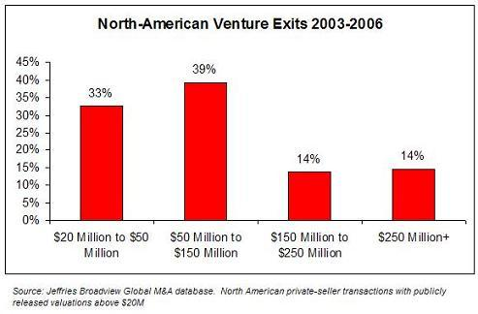
What do these three trends mean? I believe that under certain circumstances, they argue that that high valuations in a Series B/C round are not always the best thing for entrepreneurs. Now before you go off saying that as a VC I have a reason to advocate for lower valuations, wait a second. My firm, First Round Capital, is a seed-stage investor. As the first money in, our interests tend to be aligned with entrepreneurs -- if the company gets a high valuation for a Series B or C round, both the entrepreneur and my firm experience less dilution. And if the company takes a lower valuation, we both get diluted. So we have a pretty good reason to try to maximize valuation. However, in many cases I think that might be shortsighted.
When a company gets a term sheet with a high valuation, they need to pay attention to the unwritten term on the term sheet. Specifically, they should make sure they are comfortable with the exit multiple that would generate the returns needed to satisfy their VC. While every situation is unique, here's a simple rule of thumb:
Series A – 10x
Series B – 4-7X
Series C – 2-4X
So, once you sign a Series B the term sheet valuing your company at a $50M premoney, you’ve basically signed up for at least a $200M exit target. With the data showing that there are fewer exits -- and those that do exit happen at lower prices -- I think it's worth considering whether you want to eliminate the head-end of the M&A curve (ie, with 72% of all exits occuring below $150M, why force yourself into the “moonshot” trajectory?).
Now, I’m all for playing to win – and going for the billion dollar outcome. However, I think there is a concrete financial value to keeping your options open. As an investor in StumbleUpon and del.icio.us, I can pretty confidently say that had either company elected to raise a Series B round -- it would have been very difficult (if not impossible) for the founders to choose to sell their companies when they did. And while Jason Calacanis believes that "there is little risk to raising too much money", I respectfully disagree. Had Jason raised a large venture round at Weblogs, Inc. I doubt he would have been in a position to accept AOL's acquisition offer.
One thing to note, I'm not saying that there aren't times where a company's progress/opportunity is so compelling, that it makes sense to decide to take the asymmetric risk and lock yourself into a big-exit trajectory. We've definitely participated in several of those deals. But I am saying that, in my experience, most entrepreneurs aren't making a conscious decision to go for the moonshot. By optimizing solely for valuation/dilution, they aren't considering the outcomes they are removing from the table, or the added risk they are taking given the changing exit landscape.
As Brad Feld concluded when he commented on Jeremy's post, they key is to "pay attention to the risks of having valuations being both too high and too low, and understand the asymmetries in those risks."
One final note -- I continue to believe what I have said over and over --that "entrepreneurs should focus on building real, long-term value" and "you can't build a company to sell it." I am not advocating that you build a company with the primary focus to sell it. What I am saying, is that too many founders are not aware that they are shutting off the majority of exits -- and therefore increasing risks -- when they accept a high valuation. When people say there is "no risk" to raising a lot of money or getting a high valuation, I think they are not looking at the current exit realities

