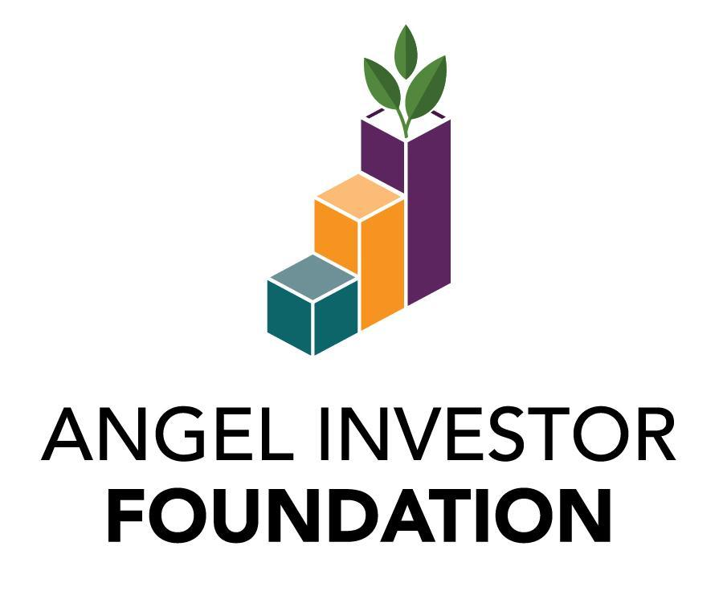
Sample Bequest Language

A bequest or other form of planned gift to the Angel Investor Foundation is a powerful expression of your support for the future of angel investing and entrepreneurship. If you would like to join others who have provided for the Foundation in this special way, simply include the following language in your will or trust:

Unrestricted Gifts
You may designate your bequest to the AIF to be used for any purpose (an “unrestricted bequest”). Those funds will be applied to the Foundation’s greatest needs at the time your bequest is realized and will provide much-needed funds to meet emerging priorities.

I, [Name], of [City, State, ZIP], give to the Angel Investor Foundation, located in Overland Park, KS, the sum of $________ [or property described herein] [or _______ percent (___%) of the rest of my estate] to be used by the Angel Investor Foundation in its discretion for general purposes.

Restricted Gifts

You may instead designate a specific purpose for your bequest (a “restricted bequest”). For example, a gift may be earmarked for entrepreneur or angel investor education.

“I, [Name], of [City, State, ZIP], give to the Angel Investor Foundation, located in Overland Park, KS the sum of $________ [or property described herein] [or _______ percent (___%) of the rest of my estate] to be used by the Angel Investor Foundation for the following purpose:_____________________.

NOTE: If you are interested in supporting a particular program area with your estate gift, the AIF board and staff would welcome the opportunity to discuss how such a gift can best align with the Foundation’s mission and be certain your wishes can be carried out in the future.

The Angel Investor Foundation strongly encourages you to consult with a qualified attorney or financial services professional to assist in the development of your estate plan. For assistance in finding a qualified attorney, please contact your local bar association. AIF stands ready to work with you and your advisors to ensure your charitable goals for the Foundation are effectively accomplished.

Contact AIF

For more information about how you can support the Angel Investor Foundation,
please contact Director of Development Katelynne Staehnke at 913-894-4700x7, or
kstaehnke@angelcapitalassociation.org.

